**WISE WORDS OF GOETHE**

**(From “**[**Conversations with Goethe**](https://www.google.com/books/edition/Conversations_with_Goethe_in_the_Last_Ye/pN1M2653ViAC?hl=en&gbpv=0)**”)**

* “No one can tell how things may draw and turn.”
* “You will find yourself perfectly competent when you have once entered on the employment; it will be very easy to you.”
* “May I find you in that state of tranquil activity, from which, after all, the most comprehensive views of the world, and the most valuable experiences, are evolved. Farewell. You must give me the pleasure of a prolonged and more intimate acquaintance.”
* “It is in my power to give you the very best means, in every way. Thus shall you lay a firm foundation for your future life, and have the pleasure of feeling yourself, in some measure, prepared for any situation.”
* “Then, I will provide you with a home in my neighborhood, and venture to predict that you shall pass no unprofitable moment during the winter. Many good things are collected in Weimar, and you will gradually find out, in the higher circles, society not surpassed in any of the great cities. And many men of great worth are connected with me, whom you also will know, and whose conversation you will find in the highest degree useful and instructive."
* "Beware of attempting too large a work. That is what injures most our best minds, and prevents fine talents and earnest efforts from accomplishing adequate results. I have suffered from this cause, and know how pernicious it is. What valuables I have let fall into the well ! If I had written all that I well might, a hundred volumes would not contain it."
* “The Present will have its rights; and the thoughts and feelings which daily press upon the poet should find a voice. But, if you have a great work in your head, nothing else prospers near it, all other thoughts must be repelled, and the pleasantness of life is quite lost, till it is accomplished. What concentration of thought is required to plan and round it off as a whole within the mind, what powers, and what a tranquil, undisturbed situation, to make it flow out as it should! If you have erred in your plan, all your toil is lost; and if, in treating so extensive a subject, you are not perfectly master of your materials, the defects in details lay you open to censure; and, after all his toil and sacrifice, the poet meets, instead of praise and pleasure, nothing but dissatisfaction and blame, which palsy his energies. But if he seizes and treats, in freshness of feeling, what the present moment offers him, he makes sure of something good, and if he does not succeed, has at least lost nothing.”
* “I did so but nobody conforms to the instructions of us old people. Each thinks he knows best about himself, and thus many lose their way entirely, and many wander long in wrong directions; and, besides, you should not wander now we of a former day have done it long to find the true path for you; and what was the use of all our seeking and blundering, if you young people will not avail yourselves of the experience we have gained? Our errors were pardoned because no track had been opened for us; but from men of a later day the world asks more they must not be seeking and blundering, but use the instructions of their predecessors to enter at once on the right path. It is not enough to take steps which may sometimes lead to an aim; each step must be in the right direction, and, at the same time, with each some separate object must be attained.”
* “Bear these words away with you, and see if you cannot from them draw somewhat for yourself. Not that I feel troubled about you, but I may be able to abridge an unprofitable stage in your progress. Fix your attention on subjects which every day offers you, and on which you can work at once with earnestness and cheerfulness; you will, in all probability, please yourself, and each day will bring its own peculiar joy. You can give what you do to the pocket-books, to the periodicals, but never submit yourself to the judgment of other minds; your own is the only true guide.”
* “The world is so great and rich, and life so full of variety, that you can never want occasions for poems. But they must all be occasional poems; that is to say, reality must give both impulse and material for their production. A particular case becomes universal and poetic when managed by a poet. All my poems are occasional poems, having in real life, by which they were suggested, a firm foundation. I attach no value to poems woven from the air.”
* 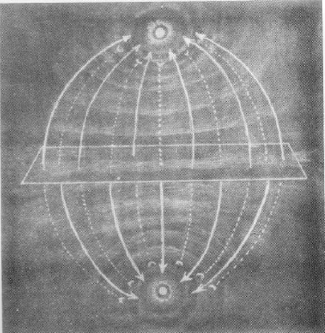“Let no one say that reality wants poetical interest; for in this doth the poet prove his vocation, that he has the art to win from a common subject an interesting side. Reality must give the impulse, the subject, the kernel, as I may say; but to work out a beautiful, animated whole, belongs to the poet. You know Fürnstein, sometimes called the Poet of Nature; he has written the prettiest poem imaginable, on the cultivation of hops. I have now desired him to make songs for the different crafts of working-men, particularly a weaver's song, and I am sure he will do it well, for he has been brought up among such people, and understands the subject so thoroughly, that he will treat it in a masterly manner. You cannot manage a great poem so; no part can be slighted or evaded; all which belongs to it as a whole must be interwoven and represented with precision. Youth has only one-sided views of things. A great work asks many-sidedness, and on that rock the young author splits.”
* “Tis the very case you may succeed in parts, and fail in others, with which you have had no proper means of becoming acquainted. You, perhaps, would do the fisherman well, and the huntsman ill; and if you fail any where, the whole is a failure; and,however good single parts may be, that will not atone for the want of completeness. But paint those parts to which you are competent, give each an independent being, and you make sure of something good.”
* “More especially, I warn you against great inventions; for there a comprehensive view is demanded, for which youth is seldom ripe. Further, character and views are loosened as sides from the poet's mind,and he has not the fullness desirable for future productions. And, finally, much time is lost in invention, internal arrangement, and combination, for which nobody thanks you, even supposing your design be happily accomplished.”
* “When materials are ready to the hand, all goes easier and better. Facts and characters being provided, the poet has only the task of animating them into a whole. He preserves his proper fullness, for he needs to part with but little of himself, and there is much less loss of time and strength. Indeed, I would advise the choice of subjects which have been used before. How many Iphigenias have been written ! yet they are all different, for each writer manages the subject after his own fashion.”
* “But, for the present, you had better lay aside all great undertakings. You have striven long enough; it is time that you should enter into the cheerful period of life. Working out small subjects will help you most at present.”
* “Yes, the ancients did not content themselves with great intentions merely; they knew also how to carry them into effect. We moderns have also great intentions, but want the skill and power to bring them out, full and lifelike as we thought them.”
* “But, it has a fine effect on you to be constrained to stay and hear what is bad. By this means, you are penetrated with the hatred for the bad, which gives you the clearest insight for the good. In reading, you have not this gain, you throw aside the book, if it displeases you; but, at the theatre, you are forced to your own profit.”
* “When I see great effects, I am apt to suppose great causes;”
* "We see in this architecture the flower of an extraordinary crisis. Who merely looks on such a flower will feel nothing but astonishment; while he who sees into the secret, inner life of the plant, into the stirring of its powers to unfold the flower, looks with other eyes, for he knows what he sees.”
* “What has kept its place for twenty years in the hearts of the people is pretty sure to have substantial merit.”
* “Intellect, and even poetry, cannot be denied to our modern composers of tragedy; but they do not give their subject the hues of life; they strive after something beyond their powers; and for that reason I have been led to think of them as having forced talents; - their growth is not natural.”
* Only two words would I say about your poems. You stand now at that point where you ought to break through to the really high and difficult part of art, that of seizing on what is individual in objects. You have talent, and have got a good way forward: your own will must do the rest. You were to-day at Tiefurt; that would afford a good subject for the attempt. You may perhaps observe Tiefurt for three or four visits, before you will win from it the characteristic side, and understand how to manage it; but spare not your toil; study it throughout, and then represent it. It is a worthy subject, and one which I should have used long since, but I could not; for I have lived through each event with it, and my being is so interwoven with its history, that details press upon me with over-great fulness. But you come as a stranger; let the keeper tell you all the history of that castle, and you will seize only what is prominent and significant at the present moment.
* "I know well that it is difficult; but the apprehension and representation of the individual is the very life of art. Besides, while you content yourself in generalities, every one can imitate you; but, in the particular, no man can, because no man has lived exactly your life."
* “And you need not fear lest what is peculiar should not meet with sympathy. Each character, however peculiar it may be, and each object which you can represent, from the stone up to man, has generality; for there is repetition every where, and there is no thing to be found only once in the world. On this step of representing what is peculiar or individual begins what we call composition.”
* "And be sure you put to each poem the date at which you wrote it. Thus, you will gain the best of journals. I have done it for many years, and can see its use."
* "Ay, and what can be more important than the subject, and what is all the science of art, if that is wanting? It is because artists in modern times have no worthy subjects, that modern art so stumbles and blunders. From this cause we all suffer. I myself must pay the penalty of my mod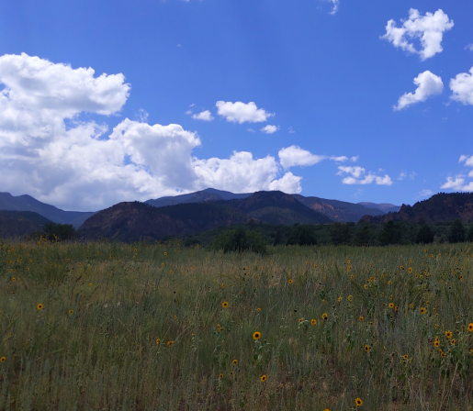ern date.”
* "Very few artists have clear notions on this point, or know the things which are for their peace. For instance, they take my 'Fisherman' as the subject of a picture, and never discover that what constitutes its merit cannot be painted. The ballad expresses the charm which the water in summer has for us when it tempts us to bathe; that is all, and how can that be painted?"
* “Each traveller should know what he is fit to see, and what properly belongs to him, on his journey.”
* "All these excellent men, with whom you are now placed in so pleasant a relation, make what I call a home, a home to which one is always willing to return."
* “Only persist in your present view, and hold fast by the present. Each situation--nay, each moment--is of infinite worth; for each represents a whole eternity.”
* “The didactic, descriptive form, would be the one I should choose; but even that is not perfectly appropriate. Perhaps you would do well to write ten or twelve little poems, in rhyme, but in various measures and forms, such as the various sides and views demand, on which light must be thrown to do justice to the subject.”
* "A comprehensive, great whole, is so difficult, that he who attempts it, seldom brings any thing to bear."
* “Ah, the public!”
* "I think not, that is well for pictures, but, as a poem is already expressed in words, words of interpretation only annihilate its significancy."
* "It was sorrowful to see how so highly gifted a man tormented himself with systems of philosophy which would no way profit him. Humboldt has shown me the letters which Schiller wrote to him in those unblest days of speculation. There we see how he plagued himself with the design of separating perfectly naïve from sentimental poetry. For such poetry he could find no proper groundwork, and from the attempt arose unspeakable confusion. As if sentimental poetry could exist without the naïve ground in which it properly has its root."
* "On the other hand, it was contrary to my nature to talk over my poetic plans with any body; even with Schiller. I carried them about with me in silence, and usually said not a word to any one till the whole was completed."
* "You see the product of a highly impassioned mood. While I was in it, I would not for the world be without it, and now nothing would tempt me to be in it again.”
* "That, may be because I looked at the present moment as a man does upon a card on which he has staked a considerable sum, and sought to enhance its value as much as I could without exaggeration."
* "Ah, I am not impatient; I have lived through too many such situations, not to have learned to endure and to wait."
* 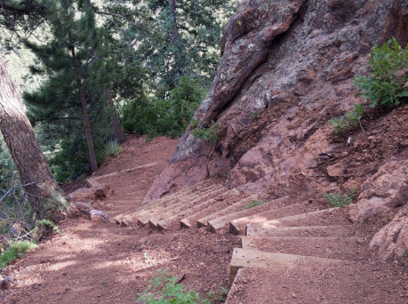"I wish, to recommend rising talent to your observation. I wish you to examine whatever our literature brings forth worthy of note, and to place before me whatever is most meritorious, that I may take due notice of what is good, noble, and well executed, in Kunst und Alterthum. For, if I am ever so desirous, I cannot, at my age, and with my manifold duties, do this without aid from other minds."
* "If I am to compose for a poem, I try to get a clear understanding of all the words, and to bring the situation before me in the colors of life. I then read it aloud till I know it by heart, and afterwards, while I am reciting it, comes the melody of its own accord."
* “Truly, the most important part of a man's life is that of development, and mine is contained in the minute disclosures of the Dichtung und Wahrheit. Later begins the conflict with the world, and that is interesting only in its results.”
* “And then the life of a literary man here in Germany, what is it? What was really good in mine cannot be communicated, and what can be communicated is not worth the trouble. And where are the hearers whom one could entertain with any satisfaction? When I look around, and see how few of the companions of earlier years are left to me, I think of a summer residence at a bathing-place. When you arrive, you first become acquainted with those who have already been there some weeks, and who leave you in a few days. This separation is painful. Then you turn to the second generation, with which you live a good while, and become really intimate. But this goes also, and leaves us lonely with the third, which comes just as we are going away, and with which we have, properly, nothing to do.”
* “I have ever been esteemed one of Fortune's chiefest favorites; nor can I complain of the course my life has taken. Yet, truly, there has been nothing but toil and care; and, in my seventy-fifth year, I may say, that I have never had four weeks of genuine pleasure. The stone was ever to be rolled up anew. My annals will testify to the truth of what I now say. The claims upon my activity, from within and without, were too numerous.”
* "What really made me happy was my poetic mind and creative power. And how was this disturbed, limited, and hindered, by the external circumstances of my condition! Had I been able to abstain from mingling in public business, I should have been happier, and, as a poet, should have accomplished much more. But, as it was, my Goetz and Werther verified for me that saying of the sage, 'If you do any thing for the advantage of the world, it will take good care that you shall not do it a second time.'"
* "A wide-spread celebrity, an elevated position in the world, are good things. But, for all my rank and celebrity, I am still obliged to be silent, lest I come into collision with the opinions of others. This would be but poor sport, if I did not by this means learn the thoughts of others without their being able to scrutinize mine.”
* “Man can conform perfectly to that situation only, in which, and for which, he was born.”
* 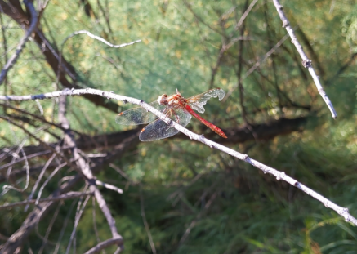"Every where, they teach in academies too many things, and many useless things. In former days, the physician learned chemistry and botany, to aid him in his profession, and they were in such a state that he could manage them. Now, each of these departments has become so extensive, that any competent acquaintance with it is the work of a life; yet acquaintance with both is expected from the physician. That cannot be; one must be renounced or neglected for the sake of the other. He who is wise will put aside all claims which may dissipate his attention, and determine to excel in some one branch."
* “We see how the inadequate dogmas of the church work upon a free mind like Byron's, and how throughout such a piece he struggles to get rid of the doctrine which has been forced upon him. The English clergy will not thank him; but I shall be surprised if he does not take up biblical subjects of similar import, and, among others, that of the destruction of Sodom and Gomorrah.”
* "Could intellect and high cultivation, indeed become the property of all, the poet would have fair play; he would be true to himself throughout, and would not fear to tell his best thoughts. But, as it is, he must always keep on a certain level; must remember that his works will be read by a mixed society; and must take care not to do any thing which by over-great openness may annoy the majority of good men. Then, Time is a tyrant, who has strange whims, and turns a new face to each new century. We cannot, with propriety, say things which were very proper for the ancient Greeks; and the Englishman of 1820 cannot endure what suited the vigorous contemporaries of Shakspeare; so that the present day finds it necessary to have a family Shakspeare."
* “the mysterious influence of different poetic forms is very great.”
* "The Bourbons, deserve praise for this measure; they were not firmly seated on the throne till they had won the army, and that is now accomplished. The soldier returns more loyal; for he has, from his own victory, and the discomfiture of the many-headed Spanish host, learned how much better it is to obey one than many. The army has sustained its former fame, and shown that it is brave in itself, and can fight without Napoleon."
* “I had the great advantage of being born at a time when the world was agitated by great movements, which have continued during my long life; so that I am a living witness of the seven years' war, the separation of America from England, the French Revolution, and the whole Napoleon era, with the downfall of that hero, and the events which followed. Thus I have attained results and insight impossible to those who must learn all these things from books.”
* "What these coming years will bring I cannot The predict; but I fear we cannot expect repose. The world is not so framed that it can keep quiet; the great are not so that they will not permit misuse of power; the masses not so that, in hope of a gradual amelioration, they will keep tranquil in an inferior condition. Could we perfect human nature, we might expect perfection every where; but, as it is, there will always be this wavering hither and thither; one part must suffer while the other is at ease. Envy and egotism will be always at work like bad demons, and party conflicts find no end.”
* “The Liberals, may speak, and, when they are reasonable, we like to hear them; but the Royalists, who have the power in their hands, should not talk, but act. They may march troops, and head and hang; that is all right; -- but to argue in public prints, and try to prove that their measures are right, is not their proper way. They might talk, if they could address a public of kings.”
* 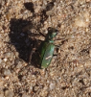"In a saucy mood, I was tempted to write some verses beneath those; but I am glad I did not. It would not have been the first time that, by indulging myself in rash liberties, I had repelled good people, and spoiled the effect of my best works."
* “'Urania' and immortality were the topics of every conversation. I could in no wise dispense with the happiness of believing in our future existence, and, indeed, could say, with Lorenzo de Medici, that those are dead for this life even, who have no hope for another. But such incomprehensible subjects lie too far off, and only disturb our thoughts if made the theme of daily meditation. Let him who believes in immortality enjoy his happiness in silence, without giving himself airs thereupon.”
* “an able man, who has something to do here, and must toil and strive day by day to accomplish it, leaves the future world till it comes, and contents himself with being active and useful in this. Thoughts about immortality are also good for those who have small success here below, and I would wager that better fortune would have brought our good Tiedge better thoughts.”
* "I used the same means with Becker, the actor, when he refused to take the part of a trooper in 'Wallenstein'. I gave him warning that, if he would not take the part, I myself would appear in it. That did the business. For they knew me at the theatre well enough to be sure that I was not in jest, and would keep my word in any case."
* "This, is the way to cultivate what we call taste. Taste should be educated by contemplation, not of the tolerably good, but of the truly excellent. I show you the best, and when you have thoroughly apprehended these, you will have a standard, and will know how to value inferior performances, without overrating them. And I show you the best in each sort, that you may perceive no department is to be despised, since each may be elevated, by genius working in it, to a source of improvement and delight. For instance, this piece, by a French artist, has a gentility which you see no where else, and is admirable in its way."
* "Certainly, the poet knows by instinct how to represent the region of love, hate, hope, despair, or by whatever other names you may call the moods and passions of the soul. But he knows not by instinct how courts are held, or how a coronation is managed, and, if he meddle with such subjects, must depend either on experience or tradition. Thus, in 'Faust,' I might by presentiment have known how to describe my hero's weariness of life, and the emotions 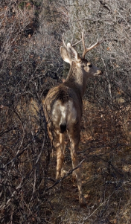which love excites in the heart of Margaret; but the lines,   
    
  Wie traurig steigt die unvollkommne Scheibe  
  Des späten Monds mitfeuchter Glut heran!  
    
  How gloomily does the imperfect orb  
  Of the late moon arise in humid glow!   
    
  require that the writer should have observed nature."
* “Perhaps so, yet, had I not the world in my soul from the beginning, I must ever have remained blind with my seeing eyes, and all experience and observation would have been dead and unproductive. The light is there, and the colors surround us; but, if we bore nothing corresponding in our own eyes, the outward apparition would not avail us."
* "There are, excellent men, who cannot endure to do any thing impromptu, or superficially, but whose nature demands that they should fix their attention in leisurely tranquillity on any object for which they are to do any thing. Such minds often make us impatient, for we can seldom get from them what we want for the moment; but in their way the noblest tasks are accomplished."
* “People of little minds are not happy in art for its own sake; while at work they always have before their eyes what they shall get by what they are doing. Such worldly views and tendencies never yet produced any thing great.“
* "I cannot, at my present period, judge of the merit of those youthful productions. You younger people are the proper judges of them. Yet I am not inclined to find fault with those beginnings; indeed, I was then in the dark, and struggled on without knowing what it was I sought so earnestly; but I had a perception of the right, a divining-rod, that showed me where gold was to be found."
* I know no pleasanter place, in the heats of summer, than this. I planted the trees forty years ago, with my own hand; have had the pleasure of watching their growth; and have already enjoyed their refreshing shade for some years. The foliage of these oaks and beeches is absolutely impervious to the sun. In hot summer days, I sit here after dinner; and often over the meadows and the park such stillness reigns, that the ancients would say, 'Pan sleeps.'"
* “Generally, the personal character of the writer influences the public, rather than his talents as an artist. Napoleon said of Corneille, 'If he were living now, I would make him a prince'”
* 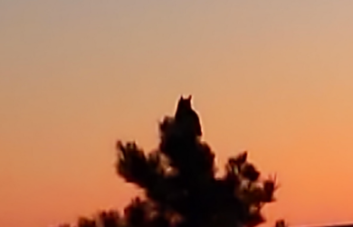"Tieck is a man of great talents, and nobody can be more sensible than myself to his really extraordinary merit; only, when they tried to raise him above his proper place, and speak of him as my equal, they made a great mistake. I do not hesitate to speak of myself as I am; I did not make myself what I am. But I might, with as much propriety, compare myself with Shakspeare, who also is, as he was made, a being of a higher order than myself, to whom I must look up and pay due reverence."
* “On the whole, the turn for philosophical speculation is an injury to the Germans, as it tends to make style vague and obscure. The stronger their attachment to certain philosophical schools, the worse do they write. Those among us who deal chiefly with practical affairs write the best. Schiller's style is noble and impressive whenever he leaves off philosophizing. I observe this in his very interesting letters, with which I am now busy.”
* "Indeed, the style of a writer is almost always the faithful representative of his mind; therefore, if any man wish to write a clear style, let him begin by making his thoughts clear; and if any would write in a noble style, let him first possess a noble soul."
* 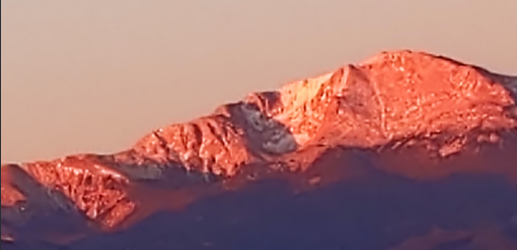"Their number is Legion; yet they may be classified with some precision. First, there are my stupid antagonists, -- those who find fault with me, because they do not understand me. This is a large company, who have wearied me extremely in the course of my life; yet shall they be forgiven, for they know not what they do.  
    
  The second class is composed of those who envy and hate me, because I have attained, through my talents, fame, fortune, and a dignified station. Should I become poor and miserable, they would assail me no more.  
    
  There are many who hate me because they have failed. In this class are men of fine powers, but who cannot forgive me, because I cast them into the shade.  
    
  Fourthly, there are my antagonists who have good reasons. For, as I am a human being, with human faults and weaknesses, it is not to be expected that my writings should be free from them. Yet, as I was constantly bent on my own improvement, and always striving to ennoble myself, I have often, as I advanced in my culture, been blamed for faults which I had long since left behind. These critics have injured me least of any, as their darts were aimed at a place from which I was already miles distant. When a work is finished, it becomes uninteresting to me; I think of it no more, but busy myself with some new plan.  
    
  Another large class comprises those who differ from me in their views and modes of thought. It is said, that on the same tree you will scarce find two leaves perfectly alike. Just so you will, among a thousand men, scarce find two, who harmonize entirely in their views and ways of thinking. This being allowed, I find less cause to marvel at my having so many opponents, than at my having so many friends and adherents. My tendencies were wholly opposed to those of my time, which were subjective; so that my objective efforts left me in solitude, and kept me at disadvantage."
* “ Schiller had, in this respect, great advantage over me. Indeed, a certain well-meaning General once gave me to understand, that I ought to write like Schiller. I replied by analyzing Schiller's merits, which I understood better than he. And I went quietly on in my own way, not troubling myself about outward success, and taking as little notice as possible of my opponents.”
* 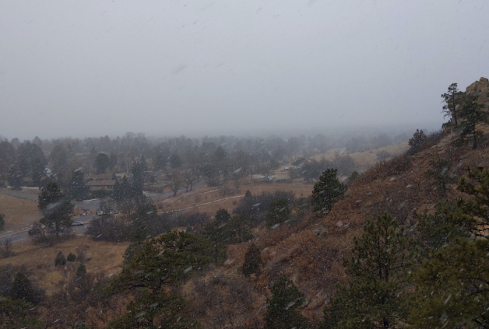"This tendency of yours is indeed likely to unfit you for society; for what would be the use of culture, if it did not teach us to modify and control our natural tendencies. 'Tis mere folly to hope that other men will harmonize with us; I have never been guided by such motives; I have regarded each man as an independent individual, whom I might study, and whose characteristics I might learn to understand, but from whom I must not expect further sympathy. Only in this way have I been enabled to converse with every man, to obtain the knowledge of various characters, and the dexterity necessary for the conduct of life. For it is by conflict with natures opposed to his own that a man learns to show himself a man. Thus only can the various sides of the character be brought out, till it attains a certain completeness, and the man feels sure of himself in opposition to any and every man. This is what you need. You can do so, if you please; and, indeed, there is no evading the great world; you must find your place in it, whether you will or no."
* "Religion, stands in the same relation to art as any other great interest of life. It is merely to be looked upon as affording material for the artist. Faith is not the faculty by which you are to comprehend a work of art; that is calculated to call into action wholly different faculties. And art must address itself to those parts of our being which are intended for the appreciation of her achievements. A religious subject may be a good one for art, but only in so far as it possesses general human interest. The Virgin with the Child is an excellent subject, and one that we may see treated a hundred tim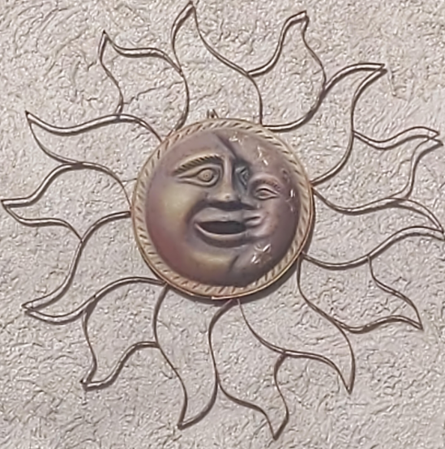es, yet not be weary."
* “At the age of seventy-five one must, of course, think frequently of death. But this thought never gives me the least uneasiness, I am so fully convinced that the soul is indestructible, and that its activity will continue through eternity. It is like the sun, which seems to our earthly eyes to set in night, but is in reality gone to diffuse its light elsewhere."
* “That a man should be able to make an epoch in the world's history two conditions are essential, that he should have a good head, and a great inheritance. Napoleon inherited the French Revolution; Frederic the Great, the Silesian War; Luther, the errors of the Popes; and I, those of the Newtonian theory. My own time has no conception of what I have accomplished; but posterity will know.”
* “The Roman history does not suit our present turn of mind. We take a more general interest in humanity, and cannot sympathize with the triumphs of Cæsar. Neither are we much edified by the history of Greece. When the whole people united against a foreign foe, then, indeed, is their history great and glorious; but the division of the states, and their eternal wars with one another, where Greek fights against Greek, are insufferable. ”
* “Make to yourself a capital that will be permanently valuable.”
* “let all go which can lead to nothing of value to you, and is not adapted to your nature”
* "Life is short; we must miss no opportunity of giving pleasure to one another."
* "Nature goes steadily her own way, and what to us appears the exception, is in reality done according to the rule."
* “No one dreams that the true power of a poem consists in the choice of situation, of *Motiven*. “
* “Whether I got it from a book or from life, is of no consequence, if I do but use it aright.”
* “For what does the whole say, but that man, despite all his follies and errors, led by a higher hand, reaches some worthy aim at last?”
* "Yes, every thing else about him was proud and majestic, only the eyes were soft. And his genius was like his outward form. He seized boldly on a great subject, turning it hither and thither, and looking at it on every side. But he saw, as I may say, only the outside of an object; he could not enter into it, and quietly unfold it from within. His talent was rather desultory. Thus he was never decided, could never be sure he had done. He often altered parts just before a rehearsal.”
* “I would only take the import of each scene, and try to express it more concisely. The piece would thus become more effective, without losing any of its peculiar beauties.”
* “That depends on the tact of the poet. If he follow the direction which the taste and interest of the public has taken, he will have no cause to complain. Houwald did this with his Bilde, and won universal applause. But the tendency of Lord Byron's mind did not coincide with that of the public. His greatness doth not here avail the poet; rather are those the greatest favorites who rise but little above the level of the public.”
* “Humanity finds its true joy, not in tearing to pieces, but in building anew.”
* “It is justly felt, and said, that the complete unfolding of all human powers is the proper aim of man. But the individual is not born for this; he must content himself with perfecting such powers as he is peculiarly endowed with, only seeking to obtain the Idea which would result from the aggregate of all these individual forces.”
* “But, on the other hand, let each man, as soon as he distinctly ascertains what he must know and do in his own department, guard himself against one-sidedness and narrow views.”
* "The great point is, that he from whom we would learn should be congenial with our nature."
* “People are always talking about originality; but what do they mean? As soon as we are born, the world begins to work upon us, and keeps on to the end. What can we call ours, except energy, strength, will? If I could give an account of what I owe to great predecessors and contemporaries, there would be but a small remainder.”
* “However, the time of life in which we are subjected to a new and important influence, makes great difference in our reception of it.”
* “He who does not expect a million readers had best never write a line.”
* "Let the poet, seize the Particular, and, if he uses it well, he cannot fail therein to represent the Universal.”
* “I could never have fully comprehended how paltry men are, and how little they care for high aims, if I had not had such opportunity to test them - in the course of my scientific researches. Now, I saw that most men only care for science in so far as they can get a living by it, and that they are ready to worship any error which they find profitable for this object.”
* “Many are full of intellect and knowledge, but they are also full of vanity; and, in their desire to shine before the short-sighted multitude, they forget all shame, all delicacy - nothing is sacred to them”
* “What know we at last, and how far can we go with all our fine wit?”
* "Man is not born to solve the problem of the universe, but to find out with what it has to do, and then restrain himself within the limits of his power of comprehension.  
    
  He cannot measure the transactions of the universe; neither his powers nor his point of view justify him in such an ambition. The reason of man and the reason of God are very different things.  
    
  If you grant God omniscience, man cannot be free; if the Divinity knows how I shall act, I must act so. I touch upon this merely as an illustration of how little we can know, and how foolish it is to meddle with divine mysteries.
* “Also, we are not obliged to utter our higher maxims, except when they can benefit the world. Let us keep them within ourselves, when they are not likely to do good without; they will not fail to diffuse over our actions the mild radiance of a hidden sun.”
* 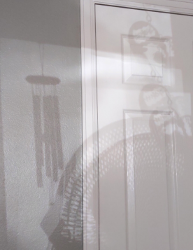"Every thing we do has its results. But the right and prudent does not always lead to good, or contrary measures to bad; frequently the reverse takes place. Some time since, I made a mistake in one of these transactions with booksellers, and was disturbed that I had done so. But, as circumstances have turned out, it would have been very unfortunate if I had not made that very mistake. Such instances occur frequently in life, and it is the observation of them which enables men of the world to go to work with such freedom and boldness."
* "Few men have any taste for faithful painting of reality; they much prefer strange countries and circumstances, in which the fancy may exercise itself unrestrained.”  
    
  "There are others, however, who cling too closely to reality, and, wholly wanting the poetic spirit, are severe indeed in their requisitions. For instance, in this very poem, some would have had me give Alexis a servant to carry his bundle, and never dreamt that all that was poetic and idyllic in the situation would have been destroyed by such an arrangement."
* “There are odd critics in this world, they blamed me for letting the hero of this romance live so much in bad company; but I considered this so called bad company, as a vase, in which I could put every thing good I had to say, and I won thereby a poetical and manifold body for my work. Had I delineated the so called good society by means of the same, nobody would have read my book.  
    
  In the seemingly mean details of 'Wilheim Meister,' lies always at bottom a high meaning, which he who has eye, knowledge of the world, and power of comprehension to infer the great from the little, will detect; to others, let it suffice to receive the picture of life as real life.”
* “It makes me feel the infinite wealth and grandeur of Shakspeare. There is nothing in human life to which he has not given form and voice; and all with what ease and freedom!”
* “Shakspeare offers us golden apples in silver dishes. We get the silver dishes by studying his works; but, unfortunately, we have nothing better than potatoes to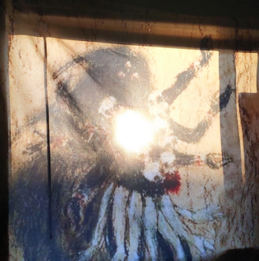 put into them.”
* “Great part of his works of negation might, I think, be fitly designated as suppressed parliamentary speeches.” (Byron)
* “Yet, let him take courage, and venture. It is in such matters as in going to bathe - disregard the first chill, and a new element is yours. Must not the singer find new tones, not natural to his throat, if he would do justice to his art? Just so with - the poet; - he deserves not the name when he only speaks out those few subjective feelings which are his as an individual. Only when he can appropriate and tell the story of the world is he a poet; and there he is inexhaustible, and can be always new, while your subjective writer has soon talked out his limited knowledge, and is ruined by mannerism. We are bid to study the ancients; yet what does that avail us, if it does not teach us to study the real world, and reproduce that? - for there was the source of the power of the ancients.”
* “I will now tell you something, of which I think you will find frequent confirmation in your experience. When eras are on the decline, all tendencies are subjective; but, on the other hand, when matters are ripening for a new epoch, all tendencies are objective. Our present time is retrograde, therefore subjective; we see this not more clearly in poetry than in painting, and other ways. Each manly effort, on the contrary, turns its force from the inward to the outward world. In important eras, those who have striven and acted most manfully were all objective in their nature. “
* “We must confess the poet oversteps the limits of decorum. He tells us truths, but truths so disagreeable, that we should love him better if he held his peace. There are things in this world, which the true poet rather conceals than discloses; but as to Byron, you might as well wish to annihilate him as wish him other than he is; so decided is his character.”
* "This young man has talent; but you should not praise, but rather scold him, for learning every thing by himself. Let no man of talent rely on his natural resources, but devote himself to art, and seek out good masters, who will show him what to do with what he has.”
* “The poet alone knows what charms he is capable of giving to his subject. It is best never to ask any body if you wish to write any thing. If Schiller had asked me about his 'Wallenstein,' I should surely have advised him against it; for I could never have dreamed that, from such a subject, so admirable a drama could be made. Schiller was equally opposed to my using hexameters. He advised me to take eight-line stanza for my Hermann and 'Dorotheà; yet he was wrong, for such rhymes would have constrained me in that careful delineation of the localities on which so much depends.”
* “If a man has freedom enough to live healthy, and work at his craft, he has enough; and each man can easily obtain this amount of freedom. Then none of us are free, except under certain conditions, which we must fulfil. The citizen is as free as the nobleman, if he will but restrain himself within the limits which God appointed by placing him in that rank. The nobleman is as free as the prince; for, if he will but observe a few ceremonies at court, he may feel himself his equal Freedom consists not in refusing to recognize any thing above us, but in knowing how to respect what is above us; for, by respecting it, we raise ourselves to it, and make manifest that we bear within ourselves the idea of what is higher, and are worthy to be on a level with it.  
    
  I have on my journeys met merchants from the north of Germany, who fancied they showed themselves my equals by rudely seating themselves next me at table. That was not the way; but they might have become so, if they had known how to value and treat me properly.”
* “If I could not say to each man something distinct and appropriate to the occasion, I preferred not writing to him at all. I esteemed superficial phrases unworthy of my use, and thus have failed to answer many excellent men to whom I would willingly have written. “
* “the ancient poems had no title; this is a custom of modern times, which also have given titles to ancient poems. Indeed, since the diffusion of knowledge, it has become necessary to give name to every thing, in order to keep literature distinct in the mind."
* “he who would write prose must have something to say; but he who has nothing to say can make verses and rhymes; for one word gives the other, till at last you have before you what in fact is nothing, yet looks as if it were something. “
* “the Chinamen think, act, and feel almost exactly like us; and we should feel perfect congeniality with them, if all they do were not more clear, more pure and decorous than with us”
* “I am more and more convinced that poetry is the universal possession of mankind, revealing itself in every place, and at all times, in hundreds of men. One makes it a little better than another, and swims upon the tide a little longer than another, that is all. Matthisson must not think he is all, nor must I think that I am all; but each must say to himself that the gift of poetry is by no means rare, and that nobody need give himself airs because he has written a good poem.”
* “But, really, we Germans are very likely to make this pedantic mistake, if we do not take heed to look beyond the narrow circle which surrounds us. I therefore gladly make excursions to other countries, and advise every one to do the same. National literature is now rather an unmeaning term; the epoch of World literature is at hand, and each one must strive to hasten its approach. But, while we know how to value what is foreign, we must not fix our attention on any thing in particular, as the only pattern and model. We must not think the Chinese are a model, or the Servian, or Calderon, or the Nibelungen. If we want examples, we had best return to the ancient Greeks, in whose works the All beauty of manhood is constantly represented. the rest we must look at historically, appropriating what is good in them, so far as we can use it”
* “Why should there be poets, if they only repeated the record of the historian. The poet must go further, and give us, if possible, something higher and better. “
* “Therefore were the Greeks so great, because they looked less to fidelity to historic facts than to the management of them by the poet.”
* “To give dignity to a simple subject, by a masterly way of treating it, demands intellect and genius, such as we rarely find.”
* “Thus you see once again the advantage of having a great predecessor, and the profit of knowing how to avail yourself of his labors.”
* "I must ever repeat it, the world could not exist, if it were not so simple. This ground has been tilled a thousand years, yet its powers remain ever the same; a little rain, a little sun, and each spring it grows green again."
* “take a glance into a state of education We and literature of which people now have no idea.see interesting men, but they do not act in the same direction and for common interests; each one takes his own way, without sympathizing at all in the exertions of others; they are like billiard balls, which run blindly by one another on the green cover, and, if they come in contact, it is only to recede so much the farther from one another.”
* "But the beauty of my connection with Schiller was, that we found the strongest bond of union in our exertions to reach a common aim, and had no need of what is commonly called friendship."
* “So strong is my faith in the barometer”
* “I think of the earth and her atmosphere as a great living being, always engaged in inspiration and expiration. If she draws in her breath, then draws she the atmosphere to her, so that, coming near her surfaces, it is condensed to clouds and rain. I call this state the affirmation of water, (Wasser-bejahung.) Should it continue an unusual length of time, the earth would be drowned; but she expires her breath again, and the watery vapors are pushed up, and so dissipated in the higher atmosphere, that not only the sun can pass through them, but the eternal darkness of infinite space seems a fresh blue. This state of the atmosphere I call the negation of water (Wasser-verneinung.) For, as under the contrary influences not only water comes profusely from above, but also the - moisture of the earth cannot be dried and dissipated, - so under these not only no moisture comes from above, but that of the earth flies upwards; so that, if this should continue an unusual length of time, the earth, even if the sun did not shine, would be in danger of completely drying up.”
* “The thing is very simple, and I abide by what is simple and prevalent, without being disturbed by occasional deviations from the general rule. High barometer, dry weather, east wind; low barometer, wet weather, and west wind; this is the general rule by which I abide. Should wet clouds blow hither, when the barometer is high, and the wind east, or, if we have a clear sky, with a west wind, I do not disturb myself, nor lose my faith in the general rule; but merely observe how many collateral influences are to be allowed for, whose nature we do not yet understand.”
* “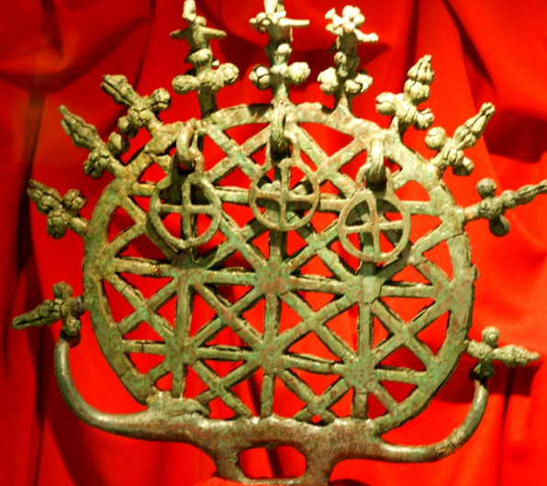I will tell you something which will be of value to your future life. There is, in nature, an accessible and inaccessible. Be careful to discriminate, with due reverence, betwixt the two. He who cannot make this distinction torments himself, perhaps his life long, about the inaccessible, without ever coming near the truth. It is, indeed, hard to say where the one ends and the other begins. But he who is prudent will labor only on what he considers the accessible; and, while he traverses every part, and confirms himself on all sides of this region, he will win somewhat even from the inaccessible, while he must confess, that only a limited insight is possible, in certain matters, and that nature has ever in reserve, problems, which man has not the faculties capable of solving.”
* “Observe how the Mohammedans educate a votary. They give their young people, as religious foundation, this doctrine, that nothing can happen to man, except what was long since decreed by an overruling divinity.   
    
  With this they are prepared and satisfied for a whole life, and scarce need any thing further.  
    
  I will not inquire whether this doctrine is true or false, useful or pernicious, only observing that we all, without being taught, share this faith to some degree. ‘The ball on which my name is not written, cannot hit me,' says the soldier in the battle-field; and how, without such a belief, could he maintain such courage and gayety, in the most imminent peril? What we are taught in our Christian law, 'No sparrow falls to the ground without the consent of our Father,' comes from the same source, intimating that there is a Providence, which keeps in its eye the smallest things, and without whose will and permission nothing can happen.  
    
  Then the Mahommedans begin their instruction in philosophy, by affirming that nothing exists, which does not suppose its contrary. Thus they practise the minds of youth in detecting and evolving the opposite of every proposition; from which arises great adroitness in thinking and speaking.  
    
  Truly, from such habits, doubt may arise as to what is truth; but this doubt will only incite the mind to those closer inquiries and experiments, in which alone man can find satisfaction.  
    
  You see that nothing is wanting in this doctrine, and that we, with all our systems, have got no further; and that, generally speaking, no one can get further.”
* "Yes, Lessing himself said, that if God would give him truth, he would decline the gift, and prefer the labor of seeking it for himself.”
* “The doctrine of good works, namely, that man, by good actions, and founding beneficent institutions, can avoid the penalty of sin, and win the favor of God, is Catholic. But the reformers, out of opposition, rejected such a doctrine, and declared that man must seek solely to recognize the merits of Christ, and share in his grace, which really must lead to good works. But, now-a-days, all this is mingled together, and nobody knows whence a thing comes”
* “For one who, like me, lived in two ages there is an oddity in this talk about statues and monuments, When one is erected in honor of any distinguished man, I seem already to see it cast down and trampled upon by the warriors of future days.”
* “To speak out an opinion directly and harshly is only excusable when that opinion is perfectly right; but a party, if only because it is a party, cannot be wholly in the right;“
* “Much is said of aristocracy and democracy; but the whole affair is simply this: in youth, when we either possess nothing, or know not how to value the tranquil possession of any thing, we are democrats; but, when we, in a long life, have come to possess something of our own, we wish not only ourselves to be secure of it, but that our children and grandchildren should be secure of inheriting it. Therefore, we always lean to aristocracy in our old age, whatever were our opinions in youth.”
* “Our times are so bad, that the poet can find no nature fit for his use, in the human life which surrounds him. To build himself up, Schiller seized on the two great subjects, philosophy and history; Manzoni, on history alone. Schiller's 'Wallenstein' is so great, that there will be nothing like it of the same sort; yet you will find that his powerful helpers, history and philosophy, have injured various parts of the work, and prevented its being purely poetical. And so suffers Manzoni, from a too great load of history.”
* "all the poets write as if they were sick, and the whole world a lazaretto. All speak of the miseries of this life, and the joys of the other; and each malecontent excites still greater dissatisfaction in his neighbors. This is a sad abuse of poetry, which was given us to smooth away the rough places of life, and make man satisfied with the world and his situation. The present generation fears all genuine power, and is only at home and poetical amid weakness. I have found a good word to plague these gentlemen; I will call theirs the lazaretto poetry. The genuine Tyrtæus vein endows man with courage to endure the conflicts of life.”
* “I thought that I should depart before him; but God disposes as he thinks best; and all that we poor mortals have to do, is to endure, and hold ourselves upright, as we best may, and as long as we can.”
* “I enjoy here day and night equally. Often before dawn I awake, and lie down by the open window, to enjoy the splendor of the three planets, which are at present to be seen together, and the gradual irradiation of the clouds. I pass almost the whole day in the open air, and hold spiritual communion with the tendrils of the vine, which say many good things to me, and of which I could tell you wonders. Also, I write once more poems which are not bad. Could it be permitted me, I would fain continue to live as I do now."
* “We others are always in bondage to something. The persons, the objects that surround us, have their influence upon us. The tea-spoon constrains us, if it is of gold, instead of silver, as usual. And so, paralyzed by a thousand side-views, we do not succeed, if there is any thing great in our nature, in expressing it freely. We are the slaves of objects round us, and appear little or important according as these restrain or give us leave to dilate."
* “Aristotle has better observed Nature than any modern, but he was too rash in his inferences and conclusions. We must go to work slowly and indulgently (lasslich) with nature, if we would get any thing from her.  
    
  When I had arrived at a conclusion in my inquiries, I did not expect that Nature would immediately confirm my opinion, but continued to test it by new observations and experiments, satisfied if she had the kindness occasionally to respond to my wishes. If she would not, then I took some other way to pursue her, through which, perhaps, I might find her more kindly disposed.“
* “it is desirable that you should, by degrees, make the acquaintance of all writers, foreign and domestic, that you may see how the high culture, which the poet needs, is best to be obtained."
* “I maintain rather that Nature is lavish, even prodigal; and it would show more acquaintance with her, to believe she has, instead of one single poor pair, produced men by dozens or hundreds.  
    
  When the earth had arrived at a certain point of maturity, the water had ebbed away, and the land gave signs of green, came the epoch for the creation of man. Men arose, through the omnipotence of God, wherever the ground permitted; perhaps on the heights first.  
    
  To believe that this happened, I esteem reasonable; but to attempt to decide how it happened, I esteem useless; and we will leave it to those who, having nothing better to do, busy themselves willingly with insoluble problems.”
* “Holy Writ, speaks certainly, only of one pair of human beings, whom God made on the sixth day; but the gifted men, who wrote that record, had in view their own, the chosen people; and we will not dispute the descent of that people from Adam and Eve. But we, and tall, slender men, handsomer than we, as well as the Negroes and Laplanders, had, certainly, different ancestors; and this worthy company must confess that we are, at present, a quite distinct race from the genuine descendants of Adam, and that they, at least in money-making, are greatly our superiors.”
* “we will not give ourselves up to melancholy thoughts.”
* "Dear child, I will confide to you something which may be of use to you all your life, and in many ways. My works can never be popular. He who thinks and strives to make them so is in an error. They are not written for the multitude, but only for individual men whose pursuits and aims are like my own."
* “We have, indeed, faculties to begin with; but, for unfolding them, we may thank a thousand influences of the great world, from which we appropriate what we can and what is suitable to us. I owe much to the Greeks and French; I am infinitely indebted to Shakspeare, Sterne, and Goldsmith; but, in saying this, I have not pointed out all the sources of my culture; that would be an endless, as well as an unnecessary task. What is important is to have a soul which loves truth, and receives it wherever it can find it.”
* “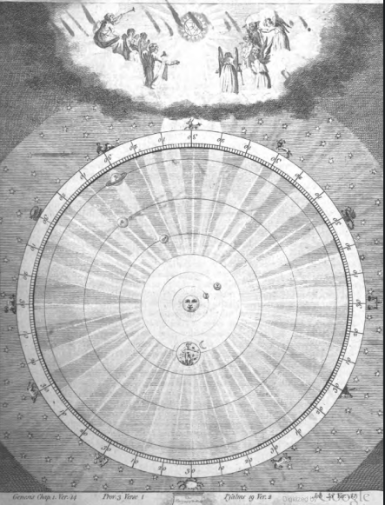His fearlessness and majesty must cultivate those who admire them. We must be careful not to confine ourselves too narrowly to what is moral and decorous. All greatness helps him who is able to apprehend it."
* “This is water for our mill. For my part, I have always kept aloof from philosophy. The stand-point of the natural human understanding was the one I preferred.”
* “Christianity has a might of its own, lifting up, from time to time, dejected, suffering humanity, and in this rises above all philosophy, and needs no support therefrom. Neither does the philosopher need the support of religion to prove certain doctrines; for instance, that existence is prolonged into eternity. Man must believe in immortality; this belief corresponds with the wants of his nature. But, if the philosopher tries to prove the immortality of his soul from a legend, that is very weak, and says little to us. To me, the eternal existence of my soul is proved, from my need of activity; if I work incessantly till my death, nature is pledged to give me another form of being when the present can no longer sustain my spirit.”
* "It must be a character true to nature and have existed more than once in the world."
* “for I took care not to write down a line that was not worthy to remain.”
* “For when a good man is gifted with talent also, he works morally for the salvation of the world, as poet, philosopher, artist, or some other way.”
* “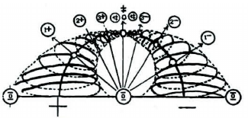The great, the wise, are always in a minority. There have been ministers who were obliged to carry through their great plans with both king and people against them. Let us not dream that Reason can ever be popular. Passions, emotions, may be made popular; but Reason remains ever the property of an elect few."
* “The plant goes from knot to knot, closing at last with the flower and the seed. So the tape-worm, the caterpillar, goes from knot to knot, and closes with the head. Man and the higher animals are built up through the vertebræ, the powers being concentrated in the head.  
    
  With corporations it is the same as with individuals. The bees form a similar scale of individuals, closing and perfected in their king. How this is. managed is a mystery, hard to be expressed in words, but I may say that I have my thoughts upon it.  
    
  Thus does a nation bring forth its hero, who stands at the head, like a demigod, to protect and save. Thus were the poetic powers of the French concentrated in Voltaire. Such heads of a nation are always great in the generation for which they work. Many have enduring life; but the majority are succeeded by others, and forgotten by after times.”
* “It is not enough to have talent: to be wise, great connections are also needed, that one may see how the cards of the time are played, and even assist oneself in winning or losing.”
* “But Nature understands no joke; she is always true, earnest, and severe; she is always right, and all failing and error must belong to man. She disdains the inadequate; only to the adequate, true, and genuine will she reveal her mysteries.”
* “The Understanding can never scale such heights. Man must rise through the highest Reason, to approach the Divinity which manifests itself in the primitive phenomena, (Urphänomenen,) physical and moral, behind which it dwells, and which proceed from it.  
    
  Divinity works in the living, and not in the dead; in the becoming and changing, not in the become and changed. Therefore Reason, aspiring to the Divine, deals with the becoming, the living; but Understanding with the become, the already stiffened, which it can apply to use.”
* “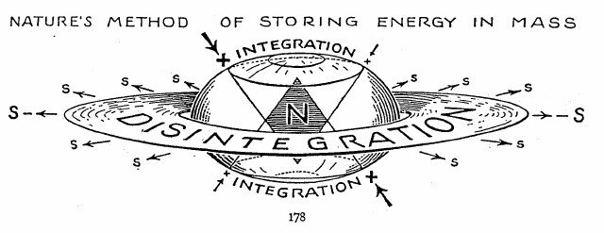This philosophy (Indian) has, if we may believe what the English tell us, nothing foreign, but rather repeats the epochs through which we all pass. While we are children, we are Sensualists; Idealists when we love, and attribute to the beloved object qualities which she does not possess. Love wavers; we doubt her fidelity, and are Skeptics before we think of it. The rest of life is indifferent; we let it go as it will, and end, like the Indian philosophers, with Quietism.”
* I have found, among my papers, a leaf, in which I call architecture frozen music. There is something in the remark; the influence that flows upon us from architecture is like that from music.  
    
  Magnificent buildings and apartments are for princes and empires. When a man lives in such, he feels satisfied, and asks no more.  
    
  This is contrary to my nature. In a splendid dwelling, such as I had at Carlsbad, I become slothful. A decent little room like this in which we are - somewhat disorderly-orderly somewhat in the gipsy fashion - is what suits me; it leaves my inner nature free to act and create.
* “The nobler a man is, so much the more is he under the influence of demons, and he must take heed and not let his guiding will counsel him to a wrong path.”
* “There is no instance on record, in which a mere statesman has been able to organize a revolutionary state, and keep under his control the military and their leaders. With the sabre in his hand, at the head of an army, a man may command and make laws, secure of being obeyed; otherwise, the attempt is hazardous. Napoleon, if he had not been a soldier, could never have attained the highest power;”
* “It is only too rich for in truth all is influence, except in so far as we ourselves are it.”
* “That is the difficult point, to decide how far it is best to keep fast hold on our natures, and allow the demons no more power than is right.”
* “great power over the mind of man has been conceded to the vegetable world which surrounds him. Surely, he who passes his life amid solemn, lofty oaks, must be a different man from him who lives among the airy 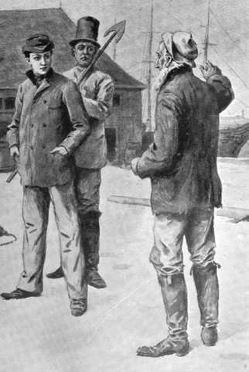birches. Yet we must remember that men, in general, have not cultivated sensibilities like us, and live away busily, without being so much affected by such impressions. Nevertheless, this much is certain: not only the inborn peculiarities of a race, but soil and climate, aliment and occupations, combine to form the character of a people. Also, we must remember that the primitive races took possession of such countries as pleased them; so that the characteristics of the country were originally in harmony with those of its inhabitants.”
* “A great ruler needs no means to make him popular other than his greatnes. If he has striven and worked to make his realm happy at home, and honored abroad, it matters not whether he ride about in a state coach, dressed in all his orders, or in a bearskin, with his cigar in his mouth, on a miserable droska. He is sure of love and esteem from his people.  
    
  But, if a prince has not this real weight and personal dignity, he had best betake himself to religion, and a sympathy with the customs of his people. To appear at church every Sunday; to look down upon, and let himself be looked at by the common people, is the best means of becoming popular which can be recommended to a young sovereign, and one which Napoleon, at the height of his greatness, did not disdain.“
* “An Italian translation of my 'Werther,' appeared at Milan. Not a single copy of it was to be had a very short time after. The bishop had bought up the whole edition. I was not vexed, but pleased by the sagacity he showed in seeing that 'Werther' was a bad book for the Catholics, and in taking such effective measures quietly to suppress it.”
* “his personal influence was great. Yet the chief reason was, that men under him were sure of attaining their object. They were drawn towards him, as they always are to him who gives them this certainty, as actors are towards the manager, on whom they can depend to assign them good parts. 'Tis an old story constantly repeated; for human nature is so constituted that no man serves another disinterestedly, but does it willingly, if thereby he can also serve himself. Napoleon knew men well; he knew how to make proper use of their weaknesses.”
* "The measure, flows spontaneously from the mood of the poet. All would be spoiled if he thought about it while writing the poem."
* “The German never thinks of others, but suits himself; and from this love of personal freedom comes indeed much that is excellent, but also much absurdity.”
* “Before and during a battle, after victory or defeat, he stood always firm, was always clear and decided what to do. He was always in his element, and equal to each situation, and each moment, just as Hummel is to an adagio or allegro, bass or treble. This facility we find wherever is real talent, in peace or war; at the harpsichord, or behind the cannon.”
* “He really visited those sick of the plague, and, indeed, in order to prove that the man who could vanquish fear, was proof against the plague also. And he was right! I could instance a similar passage in my own life, where I was exposed to infection from putrid fever, and warded it off by force of will. It is incredible what power the moral will has in such cases. It penetrates, as it were, the body, and puts it into a state of activity which repels all hurtful influences. Fear, on the other hand, induces a state of indolent weakness and susceptibility, which makes it easy for the foe to take possession of us. This Napoleon knew well, and he felt that he risked nothing in setting his army an example so imposing."
* "You see in it, a monarch whose royal dignity has not destroyed the beautiful feelings natural to him as a man - a rare phenomenon, and to be rejoiced at when seen."
* “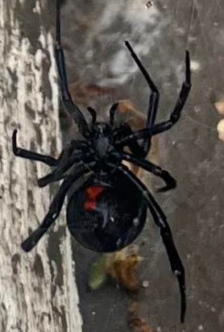Few people can realize that the poet is usually prompted to his highest efforts by slight occasions.”
* “It has from olden time been said and repeated, that man should strive to know himself. To this singular requisition no man either has fully answered or shall answer. Man is by sense and custom led outwards into the world, and has a great deal to do that he may know and make use of this. He knows himself only-from joy or sorrow, and is only in this way instructed what to seek, and what to shun. Man is a darkened being; he knows not whence he comes, nor whither he goes; he knows little of the world, and less of himself. I know not myself, and may God God protect me from it!“
* "Real talent, possesses an innate sense for form, relations, and color, so as to manage all that well with little instruction. Especially has it a sense for the corporeal, and brings it out into palpable existence, by judicious distribution of the lights. In the intervals of practice it pauses not, but grows inwardly. Such a talent is not hard to recognize, yet best recognized by a master."
* “to one who has had, during a long life, so much intercourse as I with persons of high rank. Yet perfect nature will not do; we do not meet them man to man, but must keep within the line of a certain conventional propriety.”
* “It is bad, however, that we are so hindered in life by false tendencies, and cannot know them to be false until we are already freed from them."
* “You will be surprised at such conduct in so great a man. I explain it to myself thus: - Man cannot cast aside his youthful impressions; even bad things, to which he was accustomed in those early years, remain so dear to him that he cannot see their faults.”
* “It is difficult to say from whom so great a genius, and who lived in so remarkable a time and situation, did learn. He looked about, and appropriated every thing which could afford nourishment to his designs.”
* “What misleads young people is this: We live in a time when culture is so diffused, that it has become the atmosphere which a young man breathes; poetical and philosophical thoughts, which he has imbibed with the air he breathes, live and move within him; he fancies them his own, and utters them as such. But after he has restored to the time what it gave him, he remains a poor man. He is like a fountain, which spouts forth a little while the water which is drawn into it, but ceases to give a drop when the loan is exhausted."
* “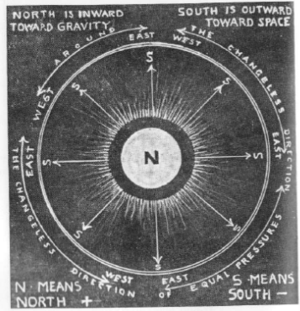I doubt not of our immortality, for nature cannot dispense with our continued activity. But we are not all, in like manner, immortal; and he who would manifest himself as a a great Entelecheia to future ages, must begin now.”
* “While the Germans are tormenting themselves with these philosophical problems, the English, with their fine practical understanding, laugh at us, and win the world. Every body knows how they have declaimed against the slave trade; and, while they have made us believe they were incited solely by motives of humanity, we at last discover that they have an object, such as they do nothing without; and this we should have known before. They themselves need the blacks, in their extensive domains on the western coast of Africa, and they do not like the trade which carries them off. They have large colonies of negroes in America, which are very profitable. From these they can supply the demand from North America, and, if slaves are brought from other places, it injures their traffic; so they preach against the inhuman African slave trade. At the Congress of Vienna, the English envoy denouncing it with great zeal, the Portuguese envoy had the good sense quietly to reply, he did not know they came together to sit in judgment on the world, or to decide upon maxims of morality. He well understood the object of England; he also had his, which he knew how to plead for and obtain.”
* “The conception (Faust part II) is now so old, for I have had it in my mind for fifty years; the materials have consequently accumulated to such a degree, that separation and choice are by no means easy. The scheme, even of the second part, is as old as I say; but it may be an advantage that I have not written it down till now, that I have so much knowledge of the world. I am like one who began life with a small sum in silver and copper money, which he has during his course exchanged again and again with such profit that he has it now in pure gold.”
* “I only meant to personify the arrogance which is natural to youth, and of which we had such striking examples after our war for freedom. A man believes, in his youth, that the world properly began with him, and that all exists for his sake.  
    
  In the East, there was a man who, every morning, collected his people about him, and never would go to work till he had commanded the sun to arise. But he was wise enough not to speak his command till the sun of its own accord was ready to appear.”
* “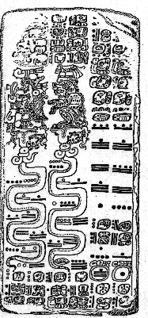I cannot but think that the demons, dallying with men, have placed among them single figures, so alluring that every one strives after them, so great that nobody can reach them. Raphael was one he whose thoughts and acts were equally perfect; some distinguished followers have come near, but none has ever equalled him. Mozart represents the unattainable I know what you in music; Shakspeare in poetry can say on the other side; but I refer to the natural dowry, the inborn wealth. Even so, none can stand by the side of Napoleon. It was great that the Russians were so moderate as not to go to Constantinople; but we find a similar trait in Napoleon - he too had the moderation not to go to Rome.”
* “The extraordinary performances of these men show that they are of uncommonly delicate organization, which makes them more susceptible to unusual emotions, and enables them to hear more easily the celestial voices. Such an organization is easily injured or destroyed by conflict with the world and the elements; and he who does not, like Voltaire, combine with great sensibility an equally uncommon tenacity, must lose his health entirely. Schiller was always sick. When I first knew him, I thought he could not live four weeks; but he had something of the tenacity I spoke of; he sustained himself many years, and would have done so longer, if he would have lived in a way more favorable to health.”
* “What the artist does or has done is sure to excite in us the self-same mood in which he did it. A free mood in the artist makes us free; a restrained one restrains us. We usually find this freedom in the artist who is fully grown up to his work. This is what pleases us in the Flemish school; those artists painted the life around them, of which they were perfect masters. An actor, to have this freedom, must, by study, fancy, and disposition, have become perfect master of his part, must have all bodily requisites at his command, and be upheld by a certain youthful energy. But study is not enough without imagination; imagination is not enough without suitableness of disposition. Women do the most through imagination and temperament; thence came the excellence of Madame Wolff.”
* "Euphorion is not a human, but an allegorical being. In him is Poetry personified, which is bound down to no time, no place, and no person. The same spirit, who is afterwards pleased to appear as Euphorion, is here the boy Lenker, like ghosts which are present every where, and can appear at any hour."
* (Eckermamm’s thoughts on the Mothers in Faust after Goethe gave him a manuscript to study): “Could we imagine that our earth had an empty space in its centre, permitting one to go hundreds of miles in one direction, without coming in contact with any thing corporeal, this might be the abode of those unknown goddesses to whom Faust descends. They do not live in any place; for nothing stands firm in their neighborhood. Neither can we attach to them the idea of time; for no heavenly body shines upon them, which, by its rising or setting, can mark the alternation of day and night.  
    
  Thus, dwelling in eternal obscurity and loneliness, these Mothers are creative beings. They are the creating and sustaining principles from which all phenomena on the surface of the earth proceed. Whatever ceases to breathe, returns in its spiritual nature to them, and they preserve it until a fit occasion rises to imbody it anew. All souls and forms of what has been, or will be, hover like clouds in the vast space of their abode.  
    
  So are the Mothers surrounded, and the magician must be able to enter their dominion, if he would obtain power over the forms of beings, and be able to call back former existences to seeming life. The eternal metamorphoses of earthly being, birth and growth, destruction and new formation, are also the unceasing care of the Mothers; and, as in all which receives new life on earth, female influences are most busy, these creating and sustaining divinities are thought of as female, and may rightly receive the title of Mothers.  
    
  Really, this is all only poetic creation; but the limited human mind cannot penetrate far into these subjects, and is well satisfied to find something on which it may rest. We see on earth apparitions, and feel influences, whose origin and aim are equally unknown to us; this leads the mind to the idea of a spiritual source of divinity, for which we have no adequate thought and no fit expression; which we must draw down to us, and anthropomorphize, in order in some measure to imbody and make comprehensible our obscure sentiments.”
* “such people as he have a fearlessness in their undertakings, which those of a different temperament cannot understand, without whose aid they would never venture on such enterprises. He takes his misfortune very coolly, and simply thinks 'I have gained an experience which will not be lost upon me.' This is the conduct of such a man as I find true pleasure in; who rises from his fall, and begins to act again immediately. “
* (Quote read by Eckerman to Goethe): “Experience is only to be gained by doing something which one would not willingly have done”
* “It has been maintained that the world is governed by pay; this I know, by examining the distribution of pay, we can find out whether it is well or ill governed.”
* “Napoleon gives us a warning how dangerous it is to rise into the region of the absolute, and sacrifice all to the carrying out of an idea.”
* "The obstinacy of the individual, and the power possessed by man of shaking off what does not suit him, is to me a proof that some such thing (Entelecheia) exists."
* “ I have been wise enough to stop short in mid career while I had yet many things in my mind to say. Thus it will be much easier to me to join on again, than if I had continued to write till I came to a stand."
* “It is not good for man to be alone. He needs sympathy and suggestion to do any thing well.”
* “You see there the spring time of a beautiful mind.”
* “The most important thing is to learn to rule oneself. If I gave way to my impulses, I have such as might ruin me and all about me.”
* "The mind is capable of incredible efforts to sustain the body. I suffer much from pain and oppression, but a strong will keeps me up. The mind need only refuse to indulge the body. Thus I cannot work as well when the barometer stands low, as when it is high: since I have observed this, I have exerted myself the more when it is low, and not without success."
* “But there are things in the way of poetry which suffer no constraint; and we must wait the favorable hour for what we cannot obtain by mental determination. So I have left myself time for my classical Carnival, that I may work upon it in the fulness of strength and serenity.”
* “The critics, now-a-days, trouble themselves greatly if in rhyme an s instead of a ss alternates with an s; such is the devotion to the technics of poetry. Were I young and daring enough, I would, intentionally, sin against their technical fastidiousness. I would use alliterations, assonances, and false rhymes, whenever they came in my way, and suited my convenience. I would fix my attention on what is important, and say such good things, that every one would be anxious to read and learn them by heart. “
* “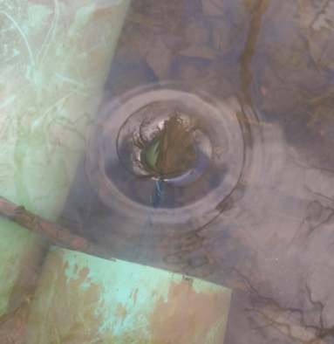Too great attention to technical minutiæ is a sign of an unproductive time and an unproductive individual.”
* "what is important in such compositions is, that the parts should be clear and significant, while the whole is incommensurable, and even on that account, like an unsolved problem, lures men to busy themselves with it again and again."
* “When one has looked about him in the world long enough, to see how the most judicious enterprises frequently fail, and the most absurd have the good fortune to succeed, he becomes disinclined to give any one advice. At bottom, he who asks advice shows himself limited; he who gives it gives also proof that he is presumptuous. If any one asks me for good advice, I say I will give it, but only on condition that you will promise not to take it."
* “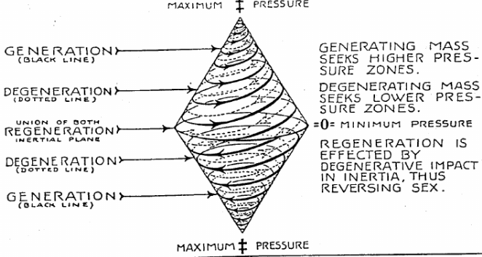You see, that none of these are manly. Good natural talents are here, that have attained a high degree of taste and skill. But manliness, (mark and underscore the word,) a certain determined energy which was always to be found in the earlier ages, is wanting to the present, not only in painting, but in all the other arts. The present is a weaker race, whether by birth, or from some fault in their education and nourishment."
* "Certainly, in art and poetry, the personality of the artist is all in all, though certain weak critics and connoisseurs of our day will not acknowledge this, and treat a grand personality as an accessory of little importance to a work.  
    
  But, really, in order to feel and admire a grand personality, a man must himself be somewhat.”
* “The musical talent may well show itself earliest of any; for it is innate; its life is within; it needs little nourishment from without, and little experience drawn from life. Really, an apparition like that of Mozart remains always an inexplicable prodigy. But how would the Divinity find every where opportunity to do wonders, if it did not sometimes try its powers on extraordinary individuals, at whom we stand astonished, unable to understand whence they come “
* “People always fancy that we cannot become wise, without becoming old also; but, in truth, as years accumulate, it is hard to keep ourselves as wise as we were. Man becomes, in the different stages of his life, indeed, a different being; but he cannot say that he will surely be a better as he goes onward, and, in certain matters, he is as likely to be right in his twentieth, as in his sixtieth year.”
* "We see the world one way from a plain, another way from the promontory, another from the glacier fields of the Alps. We see, from one of these points, a larger piece of world than from the other; but who can say that we see most truly from any one of them? When a writer leaves monuments on the different steps of his life, it is chiefly important that he should have from nature a foundation, and goodwill; that he should, at each step, see and feel clearly, and say distinctly and truly, what has passed in his mind. Then will his writings, if they were true to the season in which they originated, remain always true and right, however the writer may unfold or alter.”
* 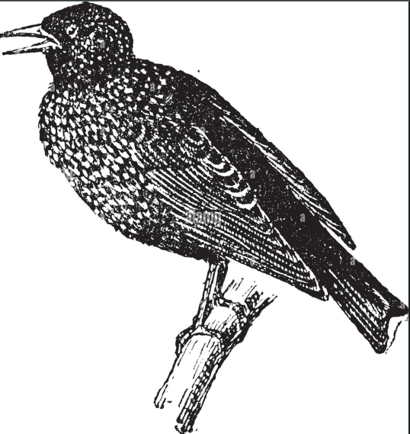“a thousand hinderances have come in our way; the enterprise has often stood still, quite refractory, and I have often cursed it in silence. But now I could do reverence to those very hinderances; for these delays have given opportunity for excellent men to ripen matters abroad, which now bring the finest water to my mill, and will bring my work to a far better conclusion than I could have imagined a year ago. The like has often happened to me in life; and thence one is led to believe in the interposition of a demoniacal power a higher influence, which we adore without presuming to explain it.”
* “I would enforce inoculation as strictly as before: these little exceptions should not be thought of when compared with the immeasurable benefits it has conferred.”
* “It is natural to man, to regard. himself as the object of the creation, and to think of all things in relation to himself, and the degree in which they can serve and be useful to him. He takes possession of the animal and vegetable world, and, while he swallows other creatures as his proper food, he acknowledges his God, and thanks the paternal kindness which has made such provision for him. He takes her milk from the cow, honey from the bee, wool from the sheep, and, while he turns these things to his own use, believes they were made for him. Indeed, he cannot believe that the smallest herb is here, except for his use, and, if he has not yet found out how to serve himself with it, doubts not he shall do so at some future time. But, if he aims at science, he soon finds that progress is inconsistent with such low views.”
* “The teachers of whom I speak would think they lost their divinity, if they did not adore him who gave the ox horns to defend himself with. But let them permit me to venerate him who was so great in the magnificence of his creations, as, after making a thousand-fold plants, to comprehend them all in one; and, after a thousand-fold animals, to make that one which comprehends them all – Man.  
    
  Further, they venerate him who gives the beast his fodder, and to man meat and drink, as much as he can enjoy. But I worship him who has infused into the world such a power of production, that, if only the millionth part of it should pass out into life, the world must swarm with creatures to such a degree that war, pestilence, fire, and water cannot prevail against them. That is my God! ”
* “I ask not whether this highest Being has reason and understanding, for I feel that He is Reason, is Understanding itself. Therewith are all creatures penetrated; and man so much so, that he can recognize parts of the Highest."
* “The difficulty with nature is, to see the law where it hides itself from us, and not to be led astray by appearances which are contradicted by our senses. Many things in nature, which are contradicted by our senses, are nevertheless true. That the sun stands still, neither rises nor sets, and that the earth turns about daily with inconceivable swiftness, contradicts our senses as much as any thing can; yet no well-instructed person doubts that it is so. Even such contradictory phenomena are found in the world of plants; and we must take heed lest they lead us astray."
* (Eckermann commenting after reading “Life” vol 4) “Many things are undertaken, but not finished; many willed, but otherwise guided; every where we feel a secret influence, a kind of Destiny, drawing out many threads for the web which future years must complete.”
* “The Demoniacal is that which cannot be explained by Reason or Understanding; it lies not in my nature, but I am subject to it.”
* “The Demoniacal manifests itself in positive active power among artists: it is found often among musicians; more rarely among painters. In Paganini, it shows itself in a high degree; and it is by means of it that he produces such great effects."
* “In poetry especially in that which is unconscious, before which Reason and Understanding fall short, and which, therefore, produces effects so far surpassing all expectation, there is always something of the Demoniacal.”
* “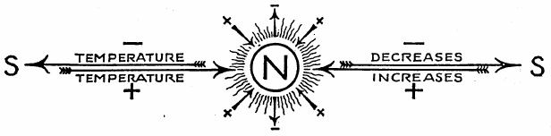The same is true of music, in the highest degree. Understanding cannot reach its elevation, and influences flow from it which master all, and of which none is able to give himself an account. Therefore cannot religious worship dispense with it; it is one of the chief means of working wonders upon men. It throws itself willingly into significant individuals, especially when they are in high places, like Frederic and Peter the Great.”
* “We read many, too many, poor things thus losing our time, and gaining nothing. We should only read what we can admire.”
* "A disposition to receive what is high, is very rare; and, therefore, in common life, a man does well to keep such things for himself, and only to give out what part seems needful to place others at some advantage."
* "Man recognizes and praises only that which he himself is capable of doing; and those who, by nature, are mediocre, have the trick of depreciating productions, which, if they have faults, have also good points, so as to elevate the mediocre productions which they are fitted to praise."
* “Yet must man exert himself to do his part; and I must, in the present instance, do my work with that care and diligence which my strength and circumstances permit. In such matters, it is like the game which the French call codille, where throws of the dice, indeed, decide in a great measure, but placing the pawns judiciously on the table is left to the discretion of the player."
* "The example of Napoleon has, especially in the young people of France who grew up under that hero, excited a spirit of egotism; and they will not rest until a great despot once again rises up among them, in whom they may see the perfection of what they themselves wish to be. The misfortune is, that a man like Napoleon will not so soon again be born; and I fear that some hundred thousands of human lives must be wasted before the world can again be tranquillized.”
* “Of literary operations there can be no thought at present; all that is to be done is quietly to prepare good things for a more peaceful time.”
* “You see in my chamber no sofa; I sit always in my old wooden chair, and never, till a few weeks ago, have permitted even a leaning-place for my head to be added. If surrounded by tasteful furniture, my thoughts are arrested, and I am placed in an agreeable, but passive state. Unless we are accustomed to them from early youth, splendid chambers and elegant furniture had best be left to people who neither have nor can have any thoughts.”
* “It (the demonical) throws itself willingly into figures of importance and prefers somewhat darkened times. In a clear prosaic city, like Berlin, for instance, it would scarcely find occasion to manifest itself.”
* “as if a man got any thing from himself but ignorance and awkwardness.”
* “He is admirable, in many respects unique; but they should not say he has all from himself. This may be said of a bad artist, never of a good.”
* “His is a talent which, independent of its alliance with party hate, would have produced no effect. There are many such instances in literature, where hatred supplies the place of genius, and where vulgar abilities make a sensation by lending themselves to be the organ of a party. So we find in life a multitude of persons who have not character enough to stand by themselves: these enlist in some party, and thus feel stronger and make some figure. Béranger, on the other hand, is a genius sufficient to itself, and therefore has never served any party. He enjoys too much satisfaction in his inner life, for the world to have power over him, either to give or to take away.”
* “I was sorry to observe this, it shows a too great tenderness of conscience, which values so highly the peculiar moral self that it will excuse nothing in it. Such a conscience makes hypochondriacal men, unless it is balanced by great activity”
* "Here, we have a subject of the highest - sort the nourishing principle which upholds the world, and pervades all nature, is brought before our eyes by this beautiful symbol. This, and others of a like nature, I esteem the true symbols of the omnipresence of God.”
* “Delivered is the noble spirit  
  From the control of evil powers;  
  Who ceaselessly doth strive must merit  
  That we should save and make him ours:  
  Celestial Love did never cease  
  To watch him from its upper sphere;  
  The children of eternal peace  
  Bear him to cordial welcome there.  
    
  These lines, contain the key to Faust's salvation. In himself, an activity becoming constantly higher and purer, eternal love coming from heaven to his aid. This harmonizes perfectly with our religious view, that we cannot obtain heavenly bliss through our own strength, unassisted by divine grace.”
* “You will confess that the conclusion, where the redeemed soul is carried up, was difficult to manage; and that I, amid these supersensual matters, about which we scarce have even an intimation, might easily have lost myself in the vague, if I had not, by means of sharply-drawn figures and images from the Christian church, given my poetical design the desirable form and compactness.”
* (After completing Faust part 2) "My remaining days, I may now consider a free gift; and it is truly of little consequence what I now do, or whether I do any thing."
* “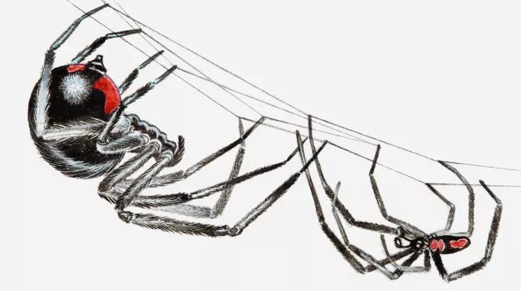The laws of poetry and painting are also communicable up to a certain degree; but, to be a good poet or painter, genius is required, which is not communicable. To receive a primitive phenomenon in its simplicity, to recognize its high significance, and work with it accordingly, demands a productive intellect, capable of taking a wide survey, and is a rare gift, only to be found in highly-favored natures.”
* “If a poet would work politically, he must give himself up to a party; and so soon as he does that, he is lost as a poet; he must bid farewell to his freedom of spirit, his unlimited prospect, and draw over his ears the cap of bigotry and blind hatred.”
* “The poet may, as a man and citizen, love his native land; but the native land of his poetic energies and poetic action is the Good, Noble, and Beautiful, which is confined to no province nor country, which he is to seize upon and body forth wherever he finds it. Therein is he like the eagle, which hovers, with free gaze, over all countries, and to which it is of no consequence whether the hare, on which he pounces down, is running through Prussia or through Saxony.”
* “And what, then, is meant by love of one's country? what is meant by patriotic deeds? If the poet has employed a life in battling with pernicious prejudices, in setting aside narrow views, in enlightening the intellects, purifying the tastes, ennobling the feelings and thoughts of his countrymen, what better could he have done? how showed himself more truly a patriot?”
* “I hate all bungling, like sin; but, most of all, bungling in state affairs, which produces nothing but mischief to thousands and millions.”
* “You know that I, generally speaking, care little what is written about me; but it comes to my ears, and I know well that, in the eyes of certain people, all my life-long toils and labors are as nothing, merely because I have disdained to mingle in party squabbles about politics. To please such people I must have become a member of a Jacobin club, preaching up bloodshed and murder; but not a word more upon this subject, lest I show myself unwise in railing against folly.”
* “Watch well and you will see the politician devour the poet. To be a 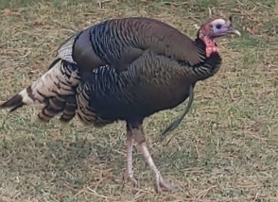member of the Estates, and live amid perpetual jostlings and excite- ments, is not the life for a poet. His song will cease soon, and that is in some sort to be lamented”

🦓